MCA Spring Conference 2026
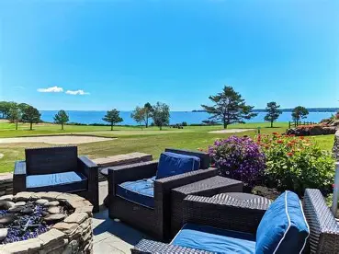
Join us as we Celebrate
The Power of Women in Chiropractic

Crystal Zagwyn, DC Heidi Haavik, DC, Ph.D Sarah Tirimacco, DC Louise Nadeau, DC
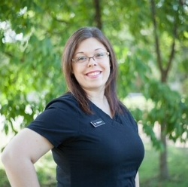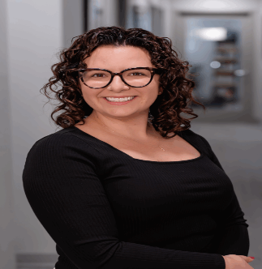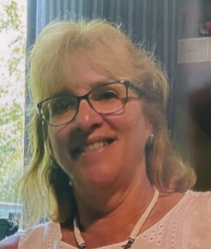
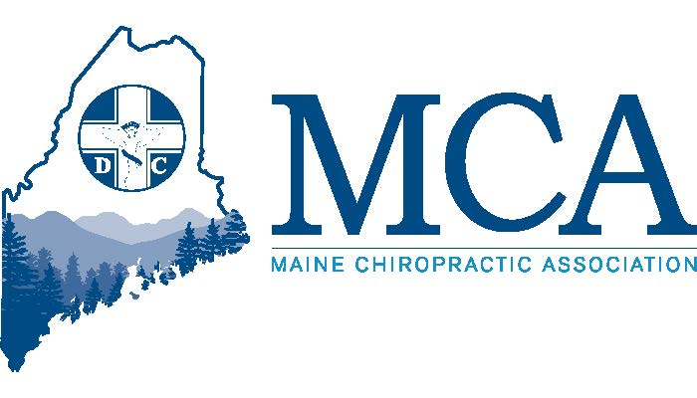

April 24th – 26th 2026 Samoset Resort, Rockport Maine
Contact the Samoset at (207) 594-2511 for rooms starting at $174 per night.
Or Go Online for Reservations - https://tinyurl.com/MCA-Samoset
Schedule
FRIDAY
5:30 PM – 7:30 PM Your dinner is provided with compliments of the MCA Chiropractic Action Fund. You will enjoy amazing food and then a presentation on “Gentle Chiropractic For Today’s Stressed Bodies” by Dr. Louise Nadeau where she will share here wisdom and insights on how modern life places increasing physical and emotional demands on both men and women. Long hours at computers, hectic schedules, emotional stress from life changes such as divorce or caregiving, challenges of raising children, and a history of accidents, all of which contribute to chronic muscle tension and discomfort.
7:00 PM – 9:00 PM An exhibitor’s welcome reception will follow for all attendees.
SATURDAY
7:00 AM – Registration & Exhibition Hall Opens
8:00 AM – 12:30 PM Morning Sessions Choose From 2 Separate Tracks (Break at 10:00 AM)
Track 1 – We welcome Dr. Sarah Tirimacco of Rochester New York, presenting “Essential Women's Health Concepts for Chiropractors”. Women’s health conditions are frequently present as common musculoskeletal complaints—low back pain, hip pain, pelvic pain, and chronic dysfunction—yet key contributing factors are often overlooked in traditional chiropractic models. This 4-hour course introduces women’s health as a clinical lens rather than a niche, equipping doctors with practical screening tools, red flags, and treatment strategies they can use immediately. Topics include pelvic floor dysfunction, pregnancy and postpartum considerations, chronic pain patterns unique to women, and how to manage these cases confidently within chiropractic scope while knowing when and how to collaborate with other providers.
Track 2 – This year, Dr. Crystal Zagwyn brings a powerful and practical presentation to the chiropractic profession—The Top 10 Mistakes in Chiropractic. Designed for real-world application, this engaging, hands-on program delivers strategies you can begin using immediately, starting Monday morning. While some topics are traditionally dry or highly technical, Dr. Z brings them to life with real examples, humor, and decades of clinical insight, making the material easy to understand, memorable, and actionable.
This presentation breaks down the most common mistakes chiropractors make—clinically, professionally, and operationally—and shows you how to avoid them. You will walk away with practical tools, refined techniques, and a clearer path toward building a confident, successful, and sustainable practice.
Just added – Staff Track for HIPAA and Compliance training Saturday Morning
12:45 PM – 1:45 PM MCA Members Business Meeting & Luncheon
2:00 PM – 6:00 PM Afternoon Session – Join Heidi Haavik Presenting her latest findings since we first met her 2 years ago. She will share the research, the studies and how she helps more people understand chiropractic and the neuroscience behind chiropractic. Dr. Heidi Haavik has become known in the circle of chiropractic researchers as not only a rising star, but also one willing to do research that can have a major impact in the scientific world and how chiropractic is perceived. (8.0 CE Hours)
6:00 PM – 8:00 PM Maine Chiropractic Association Reception for all guests and exhibitors
Sunday
7:15 AM – Registration & Exhibition Hall Opens
8:00 AM – 12:30 PM Morning Session – Join Heidi Haavik as she presents the second half of her research, findings and answers your questions. Get up close and personal with one of the world’s most respected chiropractic researchers.
Meet Your Speakers

Dr. Heidi Haavik, DC, Ph.D is the Vice President Research and Dean of Research at the New Zealand College of Chiropractic. She is a chiropractor and has a PhD in human neurophysiology from the University of Auckland and is one of the most popular chiropractic speakers in the world today. She is the author of the book ‘The Reality Check: A Quest to Understand Chiropractic from the inside out’ . Dr. Haavik is the director of Haavik Research Ltd, a company that enlightens the world in the science of chiropractic. Dr. Haavik was a member of the World Federation of Chiropractic’s Research Council for ten years. She was named Chiropractor of the year in 2007 by both the New Zealand Chiropractic Association and the New Zealand College of Chiropractic Alumni Association.

Dr. Sarah Tirimacco is a women’s health–focused chiropractor, educator, and practice owner with a deep passion for supporting women through pregnancy, postpartum recovery, and athletic performance. As co-owner of Pinnacle Hill Chiropractic in Rochester, NY, she leads a multidisciplinary team of Doctors of Chiropractic and Licensed Massage Therapists while maintaining a clinical specialty in prenatal and postpartum care, pelvic health, and rehabilitation-based chiropractic. Known for her evidence-informed yet deeply human approach, Dr. Sarah is the only women’s health Active Release Techniques® (ART®) Certified Provider in Rochester and is Webster Technique certified, with advanced training in managing pelvic pain, low back pain, neuromusculoskeletal conditions, and endometriosis-related symptoms. Dr. Tirimacco also serves as the District One Representative to Clinical Compass, replacing our own Dr. Tom Augat who retired.

In addition to being the 1st Vice president of the MCA, Dr. Crystal Zagwyn serves on the ACA Council on Forensics Sciences (CFS) The CFS provides graduate and postdoctoral needs-based and evidenced-influenced educational activities, training, tools and technology recommendations to meet the current and future needs of the forensic examiner in the fields of disability determination systems or programs, impairment rating systems, independent medical examinations (IMEs), functional (work) capacity and physical assessment (Federal) systems, return to work and fitness for duty (DOT) assessment, fraud and abuse investigation, compliance issues, post payment audits, ethics issues, documentation formulation, informed consent and/or expert witness activities.
Dr. Louise Nadeau lives in Orrington Maine, where she has practiced gentle, nontraditional chiropractic care for over 40 years and comes from a family with three brothers who are also Chiropractic Doctors. Louise graduated with a BA in Biology from UMaine Fort Kent before attending Parker College of Chiropractic where she graduated Magna Cum Laude in 1987. Her continuing education includes a diplomate in Bioenergetic Synchronicity Technique (BEST), and she was frequently speaking while living and working in Dallas Texas before moving to Maine where she now practices, speaks locally and is a frequent contributor to the Maine Eagle Magazine.

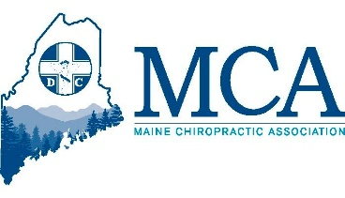
MCA EVENT REGISTRATION

Early Bird Discount (Ends 4/01/26) Late Registration
MCA Member Doctor $349.00 _____ MCA Member Doctor $399.00 _____
Non-Member Doctor $499.00 ___ Non-Member Doctor $549.00 ___
Chiropractic Students* $ 75.00 ____ Chiropractic Students $ 100.00 ___
Chiropractic Staff $ 75.00 _____ Chiropractic Staff $ 100.00 ____
Temp & Certified CA Staff $ 50.00 _____ Chiropractic Staff $ 75.00 _____
Friday Dinner Guest adult _____ $ 40.00 _____ children ______ $ 25.00
*Student Scholarships available upon request from the MCA for this event
___ Check here if you will be attending the Friday evening CE program. Dinner on Friday is included at no charge for doctors and additional dinner tickets for spouses and/or staff can be purchased for $40.00.

Attendee Name(s): __________________________________________________________________
Address: ___________________________________________ City _________________ ZIP _________
Email:_______________________________________________________________________________
Register online at www.mainechiro.com, by fax (207) 782-5482 or by mail to: MCA, 58 Albert Street Lewiston ME 04240

Payment Options:
Please charge $ _________ to my __VISA ____Mastercard _____AM EX or Check ________________(enclosed)
Cardholder Name: _________________________________Signature : _______________________________________
Credit Card # ______________________________________ Expiration Date: _____________ Zip Code: ___________

_____ Check here if you might be interested in the Friday golf outing – details to be released once we have confirmation that the course will be open.

February 16, 2026

Dear Doctor,
The MCA is excited to return to the Samoset Resort for another welcome to spring event. This is a fantastic opportunity to see old friends, learn from new instructors and support the MCA. Our Education Committee is committed to providing quality speakers, important topics and to empowering our members’ voices with opportunities to present their findings and we are excited to be working with two Maine based doctors at this event who will be presenting new information on new topics of interest. And this week we added a full Saturday morning for staff with Wendy Bell for Compliance and HIPAA Training, allowing them to also hear Heidi Haavik in the afternoon and Sunday for those staying overnight.
We will host an informal golf tournament again on Friday afternoon (weather and course conditions dependent). New this year, in your registration packet upon arrival you will find a special token to vote for the exhibitor who has the best display for our theme of “Famous Women in Chiropractic Care.” Let us see which exhibitor is the most creative as you visit their booths. Check the indicated box at bottom of registration to be added to the contact list for golfing – should conditions allow.
By the time of spring conference, we hope to formally announce our Fall Conference speakers and are finalizing those details currently. We can promise a conference that you will not want to miss attending. Mark your calendars for October 16th- 18th at the Sheraton Sable Oaks in South Portland.
The Maine Chiropractic Licensing Board currently requires 36 hours of in-person Continuing Education learning plus 12 hours of other learning each biennium and 2026 marks the first year of the biennium. All 48 hours must be complete by 12/31/2027 and prior to renewing your license.
Rooms are limited to please register early to guarantee your spot at this amazing weekend. We look forward to seeing everyone there in person. We heard you and did not increase registration costs (rooms did increase $5.00), but costs at the facility have increased significantly since COVID and we are doing everything possible to limit the costs to our doctors.
See you at the Samoset!

Robert Reed,
Executive Director, MCA

