MCA Fall Conference 2026
Join us as we welcome Dr. Deed Harrison to Maine for this exciting event!

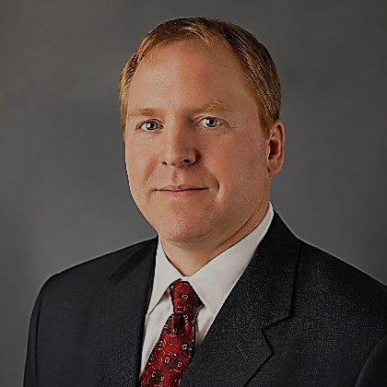

CBP* The Science of Spinal Health

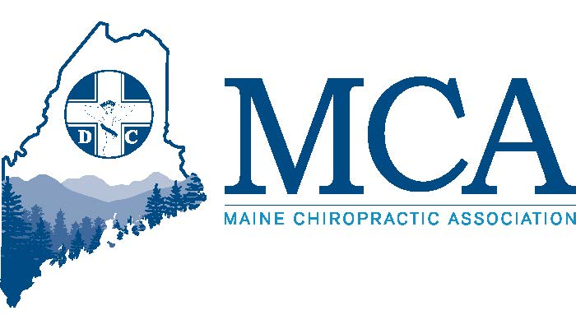
Additional tracks for Doctors and Staff

October 16th – 18th, 2026 Sable Oaks Sheraton, South Portland ME
Contact Sable Oaks at (207) 871-8000 for rooms starting at $194 per night.
Or Go Online for Reservations https://tinyurl.com/MCA-Fall-Conference

FRIDAY

5:30 PM – 7:00 PM Your dinner is provided with compliments of the MCA Chiropractic Action Fund. You will enjoy amazing food and then a presentation on TotumVos Collagen Chews by Suzanna Kamphius. Learn about her journey and the formulation using the best bovine, chicken and marine sources of collagen that transform these powders into ready-to-eat chews that provide help for your patients.
7:00 PM – 9:00 PM Join us in the Exhibitors Hall as we welcome in the newly hired Executive Director for the MCA
SATURDAY
7:00 AM – Registration & Exhibition Hall Opens

8:00 AM – 12:15 PM Morning Sessions Choose From 2 Separate Tracks (Break at 10:00 AM)

Track 1 – Join Deed Harrison for “The Sagittal Spine in Health &amp; Disease: Diagnostic
Radiographic Techniques & Their Treatments: Understanding Sagittal Balance and Curvature Abnormalities in Spine Deformities” The morning session will include Part 1 -Chiropractic diagnostic testing procedures for radiographic analysis of the spine· Diagnostic testing procedures for radiographic analysis for sagittal cervical abnormality and deformities and Part 2 - Chiropractic BioPhysics Technique Corrective Procedures for Subluxations of the Sagittal Cervical Spine
Track 2 – Join Dan Davidson of Foot Levelers to learn to “Peak My Health”. Peak My Health is not a program that patients complete. It's a systematic framework for lifetime health optimization through integrated movement medicine, metabolic restoration, brain health protection, and autonomic nervous system resilience. is not a program that patients complete. It's a systematic framework for lifetime health optimization through integrated movement, metabolic restoration, brain health protection, and autonomic nervous system resilience.
12:30 PM – 1:45 PM MCA Members Business Meeting & Luncheon
2:00 PM – 6:00 PM Afternoon Session – Choose From 2 Separate Tracks (Break at 4:00 PM)

Track 1 – Join Dr. Deed Harrison for “The Sagittal Spine in Health &amp; Disease: Diagnostic Radiographic Techniques & Their Treatments: Understanding Sagittal Balance and Curvature Abnormalities
in Spine Deformities” Part 3 – Evidence Based Measurements for Thoracic and Lumbo-Pelvic
Sagittal Spine Deformity & Part 4 - Chiropractic BioPhysics Technique Corrective Procedures for Subluxations
of the Sagittal Thoracic and Lumbo-Pelvic Spines.

Track 2 – Join Dr. Crystal Zagwyn at2:00 PM for two hours as she opens a discussion on Ethics in Todays
Office, followed at 4:00 PM by Dr. Richard Army and Avant Wellness as they present a workshop on
handheld Lasers for therapeutic applications in the Chiropractic office. During the first two hours we will focus
on the device, its uses, its focus and what the patient might gain from it as well as any concerns for the
patient. This portion of the program will be attended by staff and doctors.
Track 2 will be open to staff and doctors

SATURDAY – ALL DAY – FOR STAFF

On Saturday the MCA will host a rotation of several clinical therapeutic modalities in the morning. We are
finalizing the specific modalities now but may include Shockwave, Lasers, Ultrasound, Electric Stim, as well as a
CPR Training Course. Staff will be able to choose between two offerings at any given time and learn clinical
applications, and learn what a patient might experience as to how to safely use the equipment and treat the
patients. IN the afternoon, staff will be invited to join Doctors in Track 2 for Ethics in the Office and a Laser
presentation. Staff will be given Certificates of Completion suitable for framing for each program they omplete
that day. If your staff is attending the 2027 CA Certification Course, they will become eligible for a $50.00
discount on that program by attending this full day event. All staff are invited to lunch and to participate in all
activities that day, entertainment and treats on Saturday.

6:00 PM – 8:00 PM Maine Chiropractic Association Reception for all guests and exhibitors as we celebrate the retirement of our Executive Director Robert Reed. All guests are encouraged to wear their best Hawaiian or tropical attire and exhibitors for the weekend should have a booth featuring their favorite tropical vacation destination (but not Hawaii!).

Sunday
7:15 AM – Registration & Exhibition Hall Opens
8:00 AM – 12:15 PM Morning Sessions Choose From 2 Separate Tracks (Break at 10:00 AM)

Track 1 – This is a must for anyone in practice less than Ten Years! The MCA will host a Master Class Panel Discussion featuring several past and present leaders of the MCA offering advice and tips for the new graduates and those in practice less than ten years. During the first 2 hours we will speak to the relationships you build with fellow Chiropractors – Colleagues, not Competitors. You’ll get to know those around you who might become advisors or mentors willing to help you succeed, offering free advice on those unique patients, helping your office staff with those unusual billing questions and more. Our goal is simple – if you are successful, we all are successful! During the final Two hours we will expand the discussion and add panel members outside the Chiropractic world who are in our communities and whom you may wish to refer to or get referral from. Find out how these practices integrate well with Chiropractic how and when decisions are made to refer and how best to communicate results both positive and negative, both leading to better outcomes.
Track 2 – Join Dan Davidson of Foot Levelers to “Peak My Health”- This is a repeat of Saturdays Program for those who may have missed it.

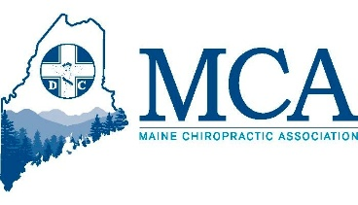
MCA EVENT REGISTRATION

Early Bird Discount (Ends 10/01/26) Late Registration
MCA Member Doctor $349.00 _____ MCA Member Doctor $399.00 _____
Non-Member Doctor $499.00 _____ Non-Member Doctor $549.00 _____
Chiropractic Students* $ 75.00 _____ Chiropractic Students $ 100.00 _____
Any Chiropractic Staff $ 100.00 _____ Chiropractic Staff $ 125.00 _____
Friday Dinner Guest adult _____ $ 40.00 _____ children ______ $ 25.00
*Student Scholarships available upon request from the MCA for this event
___ Check here if you will be attending the Friday evening CE program. Dinner on Friday is included at no charge for doctors and additional dinner tickets for spouses and/or staff can be purchased for $40.00.

Attendee Name(s): __________________________________________________________________
Additional Atttendees:_________________________________________________________________
Address: ___________________________________________ City _________________ ZIP _________
Email:_______________________________________________________________________________
Register online at www.mainechiro.com, by fax (207) 782-5482 or by mail to: MCA, 58 Albert Street Lewiston ME 04240

Payment Options:
Please charge $ _________ to my __VISA ____Mastercard _____AM EX or Check ________________(enclosed)
Cardholder Name: _________________________________Signature : _______________________________________
Credit Card # ______________________________________ Expiration Date: _____________ Zip Code: ___________

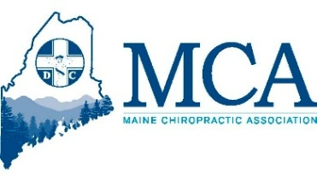
August 24, 2026
After ten years, it is amazing to look back at how far we have come in the areas of conferences, continuing education, and member engagement. I never expected that, in a single year, a small state like Maine could bring two world-class speakers to our members—but this fall, we will accomplish exactly that. We hope you will join us for our Fall Conference as we welcome Dr. Deed Harrison, appearing in his only New England presentation this fall, where he will speak on BioPhysics. Dr. Harrison has been one of our members’ most requested speakers over the past several years, and we are excited to finally bring him to Maine for the weekend.
Additional speakers and topics are listed and we Are making a special request for all doctors in practice less than 10 years not miss Sunday mornings panel discussion to learn about mentoring, communications with colleagues and referrals in your community – all designed to help you succeed. We are also excited to offer a full day of programming for Chiropractic Assistants, including modalities and ethics. This year, we will provide certificates suitable for framing in your office for each rotation your staff completes on Saturday. Staff are encouraged to join us for lunch and participate in all the other weekend activities as well. While you are with us, please take a moment to thank the members of our Education Committee—Crystal Zagwyn, Zev Myerowitz, Jr., Amber Hayes, Sarah De Preter, Jan Roberts, and Chandra Sasseville—for their tireless work finding speakers, developing topics, and helping us establish a much higher standard for continuing education in Maine.

Ten Years of Gratitude
Lastly, to all our members, I cannot thank you enough for ten amazing years. Your wisdom, encouragement, and, yes, at times your cautions, have guided me throughout my time with the MCA. From the beginning, I have tried to keep two simple principles at the center of everything I do:
Promote the Association. Protect the Association.
I often think back to that first planned session with Andre Nadeau, Greg Fox, and Dan Myerowitz, when we mapped out what this position could become and where they envisioned a new direction for the MCA. Looking back from where we are today, even I am surprised by how far we have come. But the truth is, none of it happened because of one person. It happened because of you—members who supported the association, challenged us to improve, shared ideas, attended conferences, participated in advocacy, and believed that a strong professional association matters.
I look forward to seeing everyone at the Fall Conference and, perhaps most importantly, to introducing you to our next Executive Director as we begin the transition to the next chapter of the MCA. And one final note: I am told that Saturday evening’s reception will have a tropical theme, so Hawaiian shirts and other relaxing—but appropriate—attire are encouraged. After ten years, I think we have earned a little fun!
I hope to see you all there.
Robert Reed,
Executive Director, MCA

