Committed to Chiropractic Excellence

Fall Conference 2025

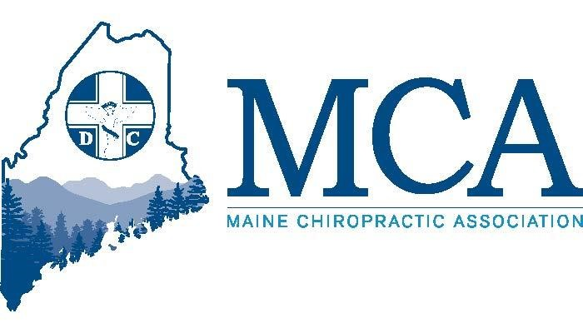

**14 CE Hours Offered (MA, NH & ME Approved)**

**3 Program Tracks All Weekend**

**(Plus, a 4th for Staff!!)**

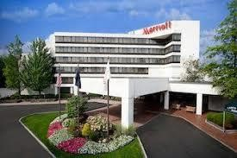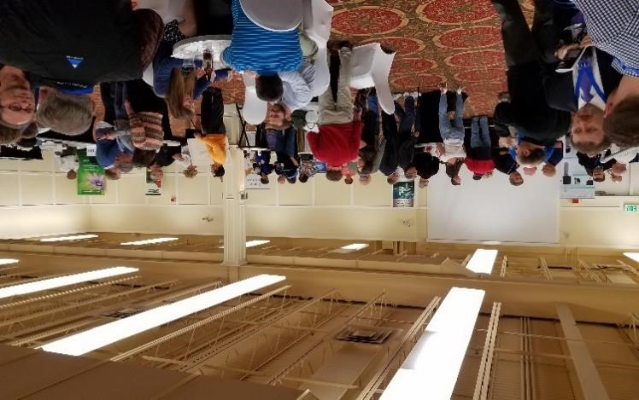

**October 17 – 19, 2025$189.00 Per Night**

**Sable Oaks Sheraton – Portland Maine**

**Sheraton Room Reservations** [**800- 752-8810**](https://www.marriott.com/event-reservations/reservation-link.mi?id=1598983445906&key=GRP&app=resvlink)

**Online Reservation Link**

**https://shorturl.at/Sn8uD**

**Meet Our Experts!**

**“Dr. Zev” Myerowitz, Jr will join us for two programs this weekend, as he hosts our Friday evening dinner presentation on the latest in regenerative medicine and why you should consider these treatments for your patients, family members and yourself. On Saturday and Sunday Dr. Zev will be our instructor for the Chiropractic Acupuncture course. Sponsorship provided by the Chiropractic Action Fund & Cape Integrative Health**

**Morgan Mullican, DC is a graduate of Palmer College and Management Coach for many Chiropractors around the country will discuss “what’s On Your Mind?” a discussion of the top 5 Chronic diseases and common health concerns of today’s patient, followed by a presentation of Pre-Diabetes and Diabetes 2. Dr. Mullican is sponsored by InvisaRed Technology.**

**After many years we are excited about the return of Activator and their speaker, Dr. Jamal DeVita. Learn what is new at Activator, how Activator can help your patients and more. This alternative to repeated use of your hands with a quick, low force impulse to the affected area can provide remarkable results. Sponsored by Activator Methods LTD.**

**Dr. Mike Housman presents a practical introduction to Artificial Intelligence (AI) in the world of chiropractic care. You will learn to use tools like ChatGPT to streamline SOAP notes, support research and improve your writing skills for your patients. Learn how you could even build a chatbot and other office applications to make your life easier and learn of the ethical considerations and future trends in AI. The MCA Chiropractic Action Fund sponsors Dr. Housman**

**Rebecca Scott of KMC University will be offering a program Saturday for staff that will revolutionize your practice’s compliant financial processes whether you are a cash practice, bill insurances yourself or one that engages in third party billing company. Your practice success relies on these basic building blocks of success, and the program is geared for any office staff and management. On Sunday Rebecca will be speaking to our doctors regarding compliance, billing and what are the hot topics in billing and compliance today.**

**Join Rob Silverman, DC as he addresses the modern healthcare paradigm shifts from disease treatment to health optimization. GLP-1 (glucagon-like peptide-1) has emerged as a pivotal hormone in metabolic regulation and the orchestration of cellular health and resilience. Dr. Silverman is sponsored by NCMIC.**

**Dr. Jamie Raymond will present his latest findings as he presents a follow-up to his extremely popular 2022 presentation. Learn how Dr. Jamie and colleagues around the country are helping their patients improve their lives through specific manipulation techniques and other treatments. Sponsored by Lifelynx.**

**The MCA – Maine’s Voice for Chiropractic**

**Our Schedule**

**Friday Evening 6:00 PM – 8:00 PM**

**All doctors are welcome to join us for a free dinner as Dr. Zev Myerowitz, Jr presents** “**Regenerative Medicine in Modern healthcare.” Enjoy a synopsis of the efficacy and applications of regenerative medicine for the chiropractic patient. Sponsored by Cape Integrative Health**

**Saturday 8:00 AM – 12:30 PM**

**Track One -** “**Acupuncture in Pediatric Applications.” This course will provide straight forward diagnostic criteria for a variety of common pediatric ailments with acupuncture and Chinese herbal treatment options.**

**Track Two – Activator**

**Track Three – Unsing Artificial Intelligence in the Chiropractic Office**

**A business lunch for all participants will take place on Saturday from 12:30 PM – 1:00 PM, followed by the MCA Members business meeting.**

**Saturday 2:00 PM – 6:30 PM**

**Track One – Acupuncture in Pediatric Applications – continued**

**Track Two - Morgan?**

**Track Three – Jamie Raymond**

**Sunday 8:00 AM – 12:30 PM**

**Track One – Acupuncture in Pediatric Applications – continued**

**Track Two - Rob Silverman**

**Track Three – Rebecca Scott**

**Staff Saturday 9:00 AM - 12:00 PM & 2:00 PM – 5:00 PM**

**Track Four - Join Rebecca Scott of KMC for Compliant Chiropractic Financial Practices - lunch included.**

**A nondenominational worship service will be held Sunday morning from 7:00 AM – 7:45 AM with Dr. Jason Davis.**

**MCA EVENT REGISTRATION**

**Early Bird Discount (Ends 9/20/25) Late Registration**

**MCA Member Doctor $349.00 _____ MCA Member Doctor $399.00 _____**

**Non-Member Doctor $499.00 _____ Non-Member Doctor $549.00 _____**

**Chiropractic Students* $ 75.00 _____ Chiropractic Students $ 100.00 _____**

**Chiropractic Staff/Spouse $ 75.00 _____ Chiropractic Staff/Spouse $ 100.00 _____**

**\*Student Scholarships may be available upon request from the MCA for this event**

**___ Check here if you will be attending the Saturday/Sunday chiropractic acupuncture program.**

**Attendee Name(s):  *__________________________________________________________________***

***____________________________________________________________________________________***

**Address: ___________________________________________ City _________________ ZIP _________**

**Email:_______________________________________________________________________________**

**Register online at** [**www.mainechiro.com**](http://www.mainechiro.com)**, by fax (207) 782-5482 or by mail to: MCA, 58 Albert Street Lewiston ME 04240**

**Payment Options:**

**_____ Check enclosed**

**Please charge $ _________ to my ____VISA ____Mastercard _____AM EX**

**Cardholder Name: _________________________________Signature : _______________________________________**

**Credit Card # ______________________________________ Expiration Date: _____________ Zip Code: ___________**

**Please Note: Exposure to COVID-19 or other transmittable pathogens is an inherent risk in any public location where people are present. The MCA cannot guarantee you will not be exposed during your visit.**