MCA Spring Conference 2024
Committed to Chiropractic Excellence

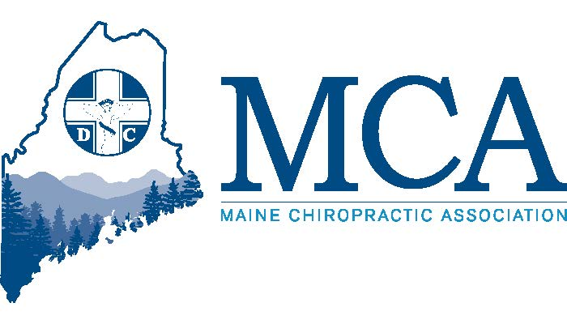

April 26th – 28th 2024 Samoset Resort, Rockport Maine
Contact the Samoset at (207) 594-2511 for rooms starting at $164 per night.
Or Go Online for Reservations - http://tinyurl.com/38xvxwhc

Our Featured Speakers
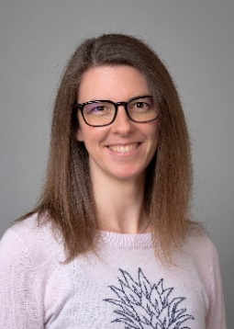
Jennifer “Dr. Jenny” Brocker is a 2007 Cum Laude graduate of Palmer College. In 2012 she became a board-certified Diplomate in Clinical Chiropractic Pediatrics having completed the required 3-year postgraduate course of study. She has also completed an 80-hour workshop series in Dynamic Balancing with Dr. Carol Philips. Dr. Jenny uses her experience as a mother and her knowledge as a chiropractor to help make pregnancy a time of joy and celebration, leading to a positive birth experience.

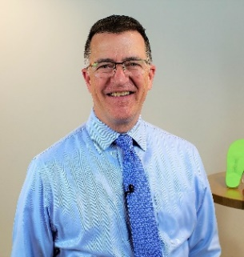
Dr. Brian Jensen is a Palmer College graduate in 1987 and has become a nationally recognized speaker on the topics of biomechanics, patient assessment, the effect of stress on the nervous system and function/functional rehabilitation. In his own words “ Staying healthy is a proactive process, doing the right things as part of a healthy life style.”

Dr. Cindy M. Howard is a Board-Certified Chiropractic Internist and Nutritionist in private practice in Chicago, Illinois and holds a license in the state of Florida. She speaks nationally, presenting on topics including Pre and Post Concussion Nutrition, Neuro-adrenal dysfunction and Infection in sport, Male and Female pelvic disorders, Pediatrics, Immunology, GI disorders, Endocrinology, Nutritional Blood analysis interpretation and genetics. She is also the author of “Positively Altered.”

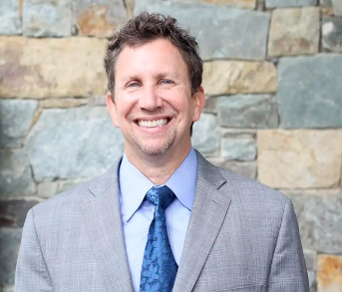
Dr. Jay Greenstein founded Kaizo Health which has a chiropractic rehabilitation center but has since expanded into other parts of the wellness sector. Kaizo Health is a premier practice consulting partner growing the latest technologies and research and making holistic, evidence-based care more accessible.

In addition, you will also hear from several local experts on acupuncture training, diplomate programs and legislative action.
Schedule
FRIDAY
6 PM – 8 PM
Your dinner is provided compliments of the MCA Chiropractic Action Fund and our donors. You will enjoy amazing food and then enter a lively discussion with Cheryl Timberlake of Capital Insights and members of our Legislative Committee, learning and understanding the legislative process in Maine. You will leave with a better understanding of the process and how you can help most.
An exhibitor’s welcome reception will follow for all attendees.
SATURDAY
8:00 AM – 10:00 AM
Track 1 – We will host a panel forum with Cindy Howard, Jay Greenstein, and Kristi Hudson. ETHICAL PRACTICES AND COMMUNICATING EFFECTIVELY: THE SUBJECT OF SEX. This nationally recognized discussion will help guide you through the do’s and do not and help answer those “gray area” questions you may have.
Track 2 -Our first hour will feature Dr. Zev Myerowitz Sr, discussing acupuncture – what it is, and what is required for training and certification in Maine. Our second hour will be a panel discussion about the various diplomate programs, how they help your practice and what is required for training.
10: 30 AM – 12:30 PM
Track 1 – Cindy Howard will present “A Case Study in Healing and Positive Living” focusing on the patient’s needs, the struggles they may encounter and more – with a twist!
Track 2 – Jay Greenstein will present “AI Technology in Healthcare – Our Future” focusing on the latest technology and information and what we will see in the future.

SATURDAY/SUNDAY
2:00 PM – 6:00 PM Saturday & 8:00 AM – 12:30 PM Sunday
These are both 8-hour programs with new material each day.
Track 1 – “Dr. Jenny” Brocker will present “Chiropractic Management of Common Pregnancy and Pediatric Conditions”. Low back pain and pubic symphysis dysfunction are often dismissed as normal during pregnancy, but just because they are common, does not mean they are normal. This program will review these common conditions, including how they might present differently during pregnancy, adjusting tips to keep mom comfortable, and home care recommendations to keep moms feeling good.

Track 2 – Dr. Brian Jensen will present “The Changing Brain- Applying the principles of Neuroplasticity to Pain, Posture, Stress”. With a greater understanding of how the nervous system works and responds to our environment, we can now improve patient outcomes by making predictable changes to pain, postural integrity, balance, and functional movement.

MCA EVENT REGISTRATION
Early Bird Discount (Ends 4/12/24) Late Registration
MCA Member Doctor $329.00 _____ MCA Member Doctor $379.00 _____
Non-Member Doctor $429.00 _____ Non-Member Doctor $479.00 _____
Chiropractic Students $ 50.00 _____ Chiropractic Students $ 75.00 _____
Chiropractic Staff $ 50.00 _____ Chiropractic Staff $ 75.00 _____
___ Check here if you will be attending the Friday evening CE program. Dinner is included at no charge for doctors and additional dinner tickets for spouses and/or staff can be purchased for $40.00.
Attendee Name(s): __________________________________________________________________
Address: ___________________________________________ City _________________ ZIP _________
Email:_______________________________________________________________________________
Register online at www.mainechiro.com, by fax (207) 782-5482 or by mail to: MCA, 58 Albert Street Lewiston ME 04240
Payment Options:
Please charge $ _________ to my ____VISA ____Mastercard _____AM EX or Check # _________________(enclosed)
Cardholder Name: _________________________________Signature : _______________________________________
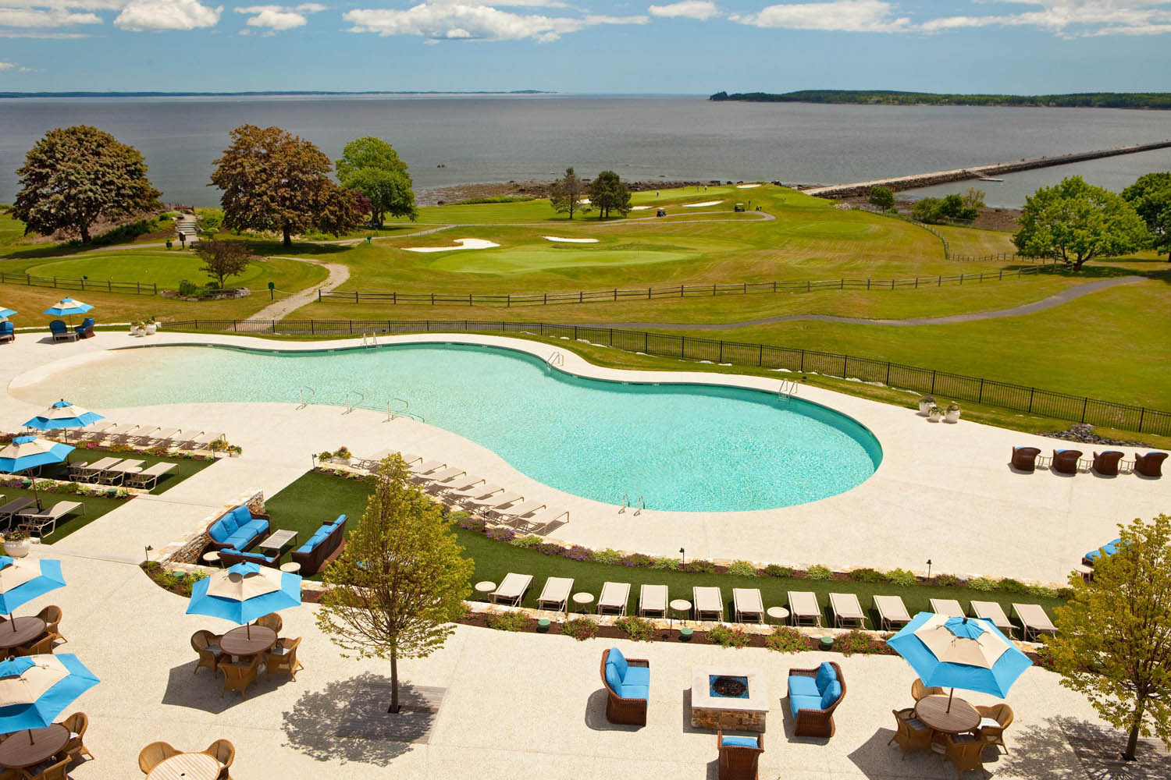
Credit Card # “ ______________________________________ Expiration Date: _____________ Zip Code: ___________

February 26, 2024
Dear Doctor,
The MCA is excited to return to the Samoset for another welcome to spring event.
Beginning this year we now have an Education Committee, and our goal is to find the most qualified speakers with the latest knowledge to share with you. Speaker sponsors will still occur, but our rules and the limitations will make these much more inviting. This spring we will also host discussion topics with experts in acupuncture training and diplomate programs and hope to answer any questions you might have surrounding either of those. Should we find enough interest in a specific diplomate we will step up and bring the program to you here in Maine (online and in person).
By the time of spring conference, we hope to formally announce our Fall Conference headliners and are finalizing those details currently. We can promise a conference that you will not want to miss attending. Mark your calendars for October 26- 28th at the Sheraton Sable Oaks in South Portland.
Due to space restrictions and limited participation in the past, we will not have a separate track for staff this spring but encourage them to hear from our speakers. The fall conference will have a featured staff speaker as I work with CAs around the state to find what best to present for their ongoing educational needs.
The Maine Chiropractic Licensing Board currently requires 36 hours of in-person Continuing Education learning plus 12 hours of other learning each biennium and 2024 marks the beginning of the biennium. All 48 hours must be complete by 12/31/2025 and prior to renewing your license.
We look forward to seeing everyone there in person. We apologize for having to raise the fees slightly, but costs at the facility have increased significantly since COVID and we do everything possible to limit costs to our doctors.
See you at the Samoset!

Robert Reed,
Executive Director, MCA

