MCA Spring Conference 2023
Committed to Chiropractic Excellence

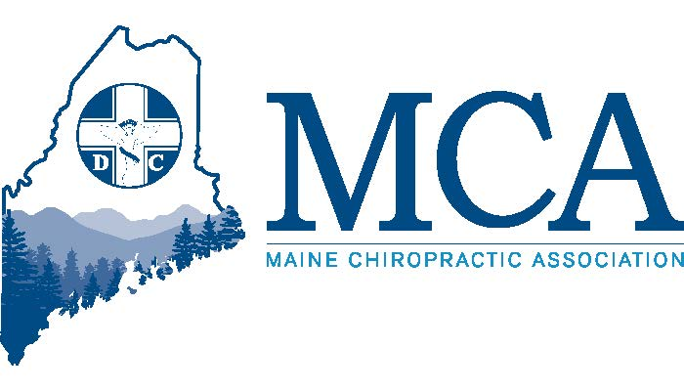

May 12th – 14th Samoset Resort, Rockport Maine
Contact the Samoset at (207) 594-2511 for rooms starting at $159 per night
Or Go Online For Reservations - https://rb.gy/efcuvu

Our Speakers

Anish Bajaj, DC is a NY/NJ Board Certified Chiropractor with 23 years in the field of chiropractic. He emphasizes dependence of health on the correct functioning of the central nervous system and provides guidance on lifestyle habits, exercise, nutrition, and stress management . Sponsored by Foot Levelers

Stephen Arsenault, DC A Parker University Graduate with over 25 years’ experience, Dr. Arsenault works to recruit Chiropractic candidates while mentoring physical medicine undergraduates at the University of Maine. He is often asked to speak on behalf of Med Cor Pro and others and happy to share his knowledge and experience in a fun and interesting way.

Don Rasmussen is a Certified Tax Coach and seasoned tax reduction strategist, having worked with many medical practices and charities throughout the United States. He provides guidance to make informed decisions, avoid costly mistakes, maximize their tax efficiency, and find the money falling through the cracks in the current financial planning. Sponsored by Quartermaster Tax Management

Plus – Each spring, we try to create a second track which is applicable to our doctors and their clinical staff. Thie year we will offer a hands-on program showcasing several different pieces of equipment that can help your patients. Speakers who can explain the clinical applications and who can be helped while you try out the equipment and learn its best use and when not to use. Whether it is lasers, Shock Wave, compression equipment, light therapy or more, these 2 hour blocks will allow you to step in and find if the equipment and clinical aspects are right for your chiropractic practice.

Schedule
FRIDAY
6 PM – 8 PM –
Join Dona Rasmussen for dinner for his presentation of “Monetizing Your Documentation Process: A Guide to Chiropractors.” This program will teach you how to monetize the process of documentation so you can streamline your workflow, increase your efficiency, and boost your bottom line. Learn the key elements of effective documentation organized for maximum benefit, using documentation to justify insurance claims and qualify for little known IRS tax credits that can be as much as $10,000 - $15,000.

An exhibitor’s welcome reception will follow for all attendees.
SATURDAY
TRACK ONE – 8:00 AM – 12:30 PM & 2:00 PM – 6:00 PM
Join Dr. Anish Bajaj as he shares with you the red flags of the chiropractic practice. In the morning you will learn about understanding patients, their biology and providing them with leadership through education and focused care. The afternoon session will be applying essential health principles towards more complete care plans.
TRACK TWO – 8:00 AM – 12:30 PM & 2:00 PM – 6:00 PM
Join a variety of speakers from our exhibitor program as they walk you through the clinical application of their equipment. This is NOT a sales pitch but will concentrate on how various equipment in use today might benefit your practice. The final schedule will be posted at the event as we anticipate allowing each participant to have Two Hours’ time allotted.

SUNDAY
TRACK ONE – 8:00 AM – 12:30 PM
Join Dr. Steve Arsenault as he shares his experiences through the years beginning as a young doctor when patients would state “I don’t even have to tell you what’s wrong, do I?” which evolved into a game of “I’m not going to tell you the problem, you have to find it.” Take away his golden nuggets of clinical wisdom allowing you to become an even better practitioner. You’ll share experiences, stories of difficult patients and you’ll be hands on practicing techniques he has learned through the years.

TRACK TWO – 8:00 AM – 12:30 PM
Join our continued variety of speakers from our exhibitor program as they walk you through the clinical application of their equipment. This is NOT a sales pitch but will concentrate on how various equipment in use today might benefit your practice. The final schedule will be posted at the event as we anticipate allowing each participant to have Two Hours’ time allotted.
MCA EVENT REGISTRATION
Early Bird Discount (Ends 4/28/23) Late Registration
MCA Member Doctor $279.00 _____ MCA Member Doctor $349.00 _____
Non-Member Doctor $379.00 _____ Non-Member Doctor $449.00 _____
Chiropractic Students $ 50.00 _____ Chiropractic Students $ 75.00 _____
Chiropractic Staff $ 50.00 _____ Chiropractic Staff $ 75.00 _____
___ Check here if you will be attending the Friday evening CE program. Dinner is included At no charge for doctors and additional dinner tickets for spouses and/or staff can be purchased for $30.00
Attendee Name(s): __________________________________________________________________
Address: ___________________________________________ City _________________ ZIP _________
Email:_______________________________________________________________________________
Register online at www.mainechiro.com, by fax (207) 782-5482 or by mail to: MCA, 58 Albert Street Lewiston ME 04240
Payment Options:
Please charge $ _________ to my ____VISA ____Mastercard _____AM EX or Check # _________________(enclosed)
Cardholder Name: _________________________________Signature : _______________________________________
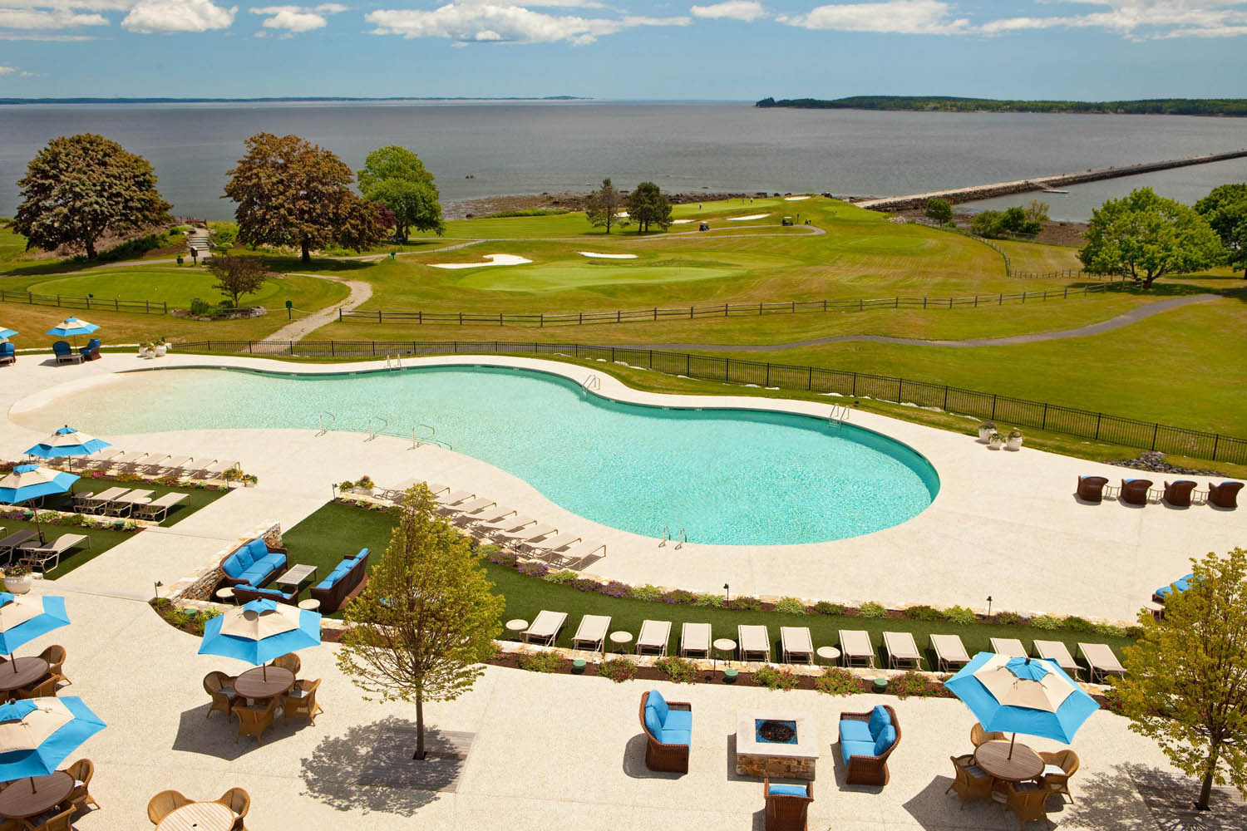
Credit Card # “ ______________________________________ Expiration Date: _____________ Zip Code: ___________

March 15, 2023
Dear Doctor,
The MCA is excited to return to the Samoset for another welcome to spring event. We continue to see vastly improving conditions as we are prepared to host a major event for our doctors and their staff.
Our goal for spring is to offer one track for doctors, and one of which is appropriate for doctors and staff . This year that second track will be hands-on as several of our exhibitors will host clinical demonstrations of their equipment designed to help your patients reach maximum improvement and good health. Final schedule of times will be posted at the event; however, we anticipate two hour sessions for each modality. These may include lasers, shock wave, electric stims, gait training light therapy, and some of the newest equipment being offered. This will not be a sales program, but a clinical program designed to instruct on use and treatment plans. Being hands on will allow you to get a feel for the equipment and determine if it’s a good fit for your practice. For those staff who are attending the 2023 Chiropractic Assistants classes this spring – registration is waived for this event as part of their course registration payment.
Also, we continue hosting more local speakers. The MCA Board of Directors has made a commitment to help Maine doctors share their voice, their research, and their abilities with others as opportunities are presented. If you have ever considered public speaking to your peers in Maine and elsewhere this is a fantastic way to showcase your unique topic, teach others and find sponsors willing to pay you to speak, help defray your costs to travel and further market your lectures. Dr. Steve Arsenault will be sharing his experiences on Sunday morning.
The Maine Chiropractic Licensing Board currently requires 36 hours of in-person Continuing Education learning plus 12 hours of other learning each biennium and 2023 marks the second part of that biennium. All 48 hours must be complete by 12/31/2023 and prior to renewing your license.
We look forward to seeing everyone there in person. Due to logistics and cost, this event will not be recorded for same time or later viewing.

See you at the Samoset!

Robert Reed,
Executive Director, MCA

