Committed to Chiropractic Excellence
Fall Conference 2023
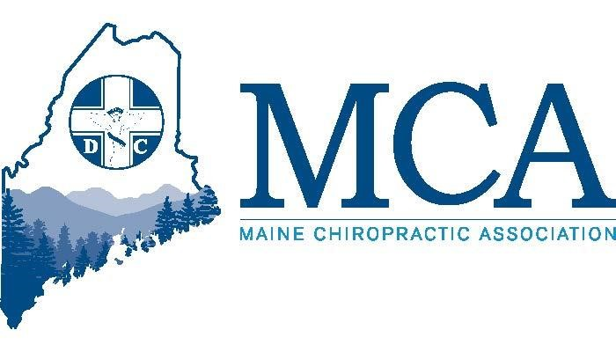
14 CE Hours Offered (MA, NH & ME Approved)
3 Program Tracks All Weekend
(Plus, a 4th for Staff!!)

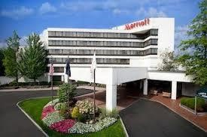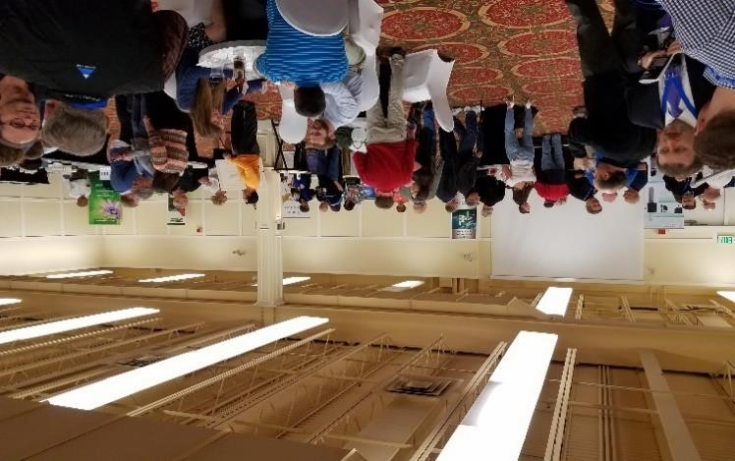
October 20 – 22, 2023$179.00 Per Night
Sable Oaks Sheraton – Portland Maine
Sheraton Room Reservations 800- 752-8810
Online Reservation Link
https://rb.gy/qo2jx
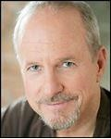
Meet Our Experts!
Ty Talcott “The Compliance Guy” - Dr. Ty Talcott is a Certified HIPAA Privacy and Security Expert, who consults thousands of healthcare practices relative to business development and protection. Sponsored by The Compliance Help Desk
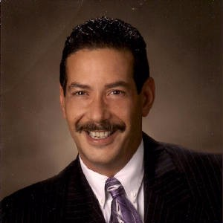
Dr. Zev J. Myerowitz Sr. is a Doctor of Chiropractic and a Licensed Acupuncturist practicing in the State of Maine for the past 45 years. He has taught over two hundred seminars in Acupuncture, Oriental Medicine, Practice building, and philosophy. Sponsored By Cape Integrative Health
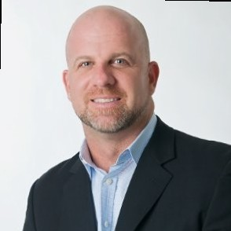
Joe Kryszak is President of Sterling Professional CBD and serves on the ChiroHeroes Board of Directors – a national organization devoted to stopping and helping victims of Human Trafficking and sex Slavery in the US. Sponsored by Chiro Heroes
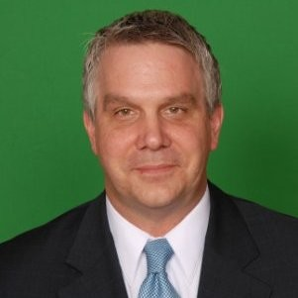
Morgan Mullican, DC is a graduate of Palmer College and a Senior Coach for Breakthrough Coaching and speaks on “Getting it right the First Day” and “The Posture Connection” among other topics. Sponsored by Breakthrough Coaching
Kathy Weidner (You may know her as Kathy Mills-Chang) is the leading authority on Chiropractic Office Practice Management. Whether it is training office staff or doctors, Kathy is the resource your office needs. Sponsored By Foot Levelers.
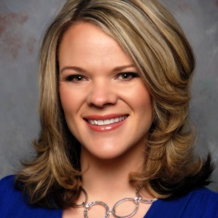
Alicia Yochum, RN, DC, is a graduate of Logan University and a leading expert on Chiropractic Radiology. We are thrilled to have her presenting the latest in Radiology to our doctors. Sponsored by NCMIC

The MCA – Maine’s Voice For Chiropractic
Our Schedule
Friday Evening 6:00 PM – 8:00 PM
All doctors are welcome to join us as Ty Talcott presents “Improving Patient Outcomes through Enhanced Staff and Patient Communications.” Dinner is provided for those attending this class.
Track One
Saturday 8:00 AM – 12:30 PM, 2:00 PM – 6:30 PM & Sunday 8:00 AM – 12:30 PM
Please join Zev Myerowitz, Sr of Myerowitz Chiropractic in Holden as he presents “Effective Acupuncture Point Combinations.” 12 Hours CE for Chiropractic Acupuncture
Track Two
Saturday 8:00 AM – 12:30 PM & Sunday 8:00 AM – 12:30 PM
We welcome Dr. Alicia Yochum to Maine to provide the latest training on chiropractic radiology.
Saturday 2:00 PM – 6:30 PM
Ty Talcott provides updates on Compliance and federal rules for 2024 and beyond.
Track Three
Saturday 8:00 AM – 12:30 PM & 2:00 PM – 4:00 PM
Morgan Mullican, DC joins us to offer “Getting It Right from Day One “, followed by “The Posture Connection” talk after lunch.
Saturday 4:30 PM – 6:30 PM
Joe Kryszak, MBA of Chiro Heroes leads an important talk “Closer to Home Than You Think – Identifying and Reporting Human Trafficking.”
Sunday 8:00 AM – 12:30 PM
Kathy Weidner addresses our doctors this morning with “Adventures in Documentation – Uncovering the Secrets of Risk Management” as well as a follow up discussion from her Saturday training session with your staff.
Track Four
Saturday 8:00AM – 12:30 PM & 2:00 PM – 6:30 PM
Kathy Weidner trains your staff with “Compliant and Consistent Cash Flow I Everyone’s Job,” as she explores how office staff can best be compliant and build and protect your practice.
A business lunch for all MCA Members will take place on Saturday from 12:30 PM – 1:45 PM

MCA EVENT REGISTRATION

Early Bird Discount (Ends 10/01/21 | Late Registration
MCA Member Doctor $ 299.00 | MCA Member Doctor | $ 399.00
Non-Member/Out of State Doctor $ 399.00 | Non-Member/Out of State | $ 499.00
Chiropractic Staff $ 75.00 | Chiropractic Staff | $ 100.00
Chiropractic Students $ 75.00 | Chiropractic Students | $ 100.00
ALL Doctors Registration includes dinner Friday during the presentation.
______ Check here if Doctor attending Friday evening dinner presentation
Attendee Name(s): __________________________________________________________________
Address: ___________________________________________ City _________________ ZIP _________
Contact Email _________________________________________________________________________
If you are a Chiropractic Action Fund donor, you may be eligible for a 50% registration rate.
Register by fax at (207) 782-5482, by email/scan to mainechiroed@gmail.com online at www.mainechiro.com or by mail to:
Maine Chiropractic Association, 58 Albert Street Lewiston ME 04240 (checks payable to Maine Chiropractic Association
Payment Options:
Please charge $ _________ to my ____VISA ____Mastercard _____AM EX or Check # _________________(enclosed) Cardholder Name: _________________________________Signature : _______________________________________
Credit Card # “______________________________________ Expiration Date: _____________ Zip Code# ___________
_____ Please check here if you will be attending the 12 Hour Acupuncture Program (for Space Planning Purposes Only)
DC Continuing Education Credit Hours for all DC Level Courses approved by ME, NH & MA

Please Note: Exposure to COVID-19 or other transmittable pathogens is an inherent risk in any public location where people are present. The MCA cannot guarantee you will not be exposed during your visit.

MCA 2023 Fall

