Committed to Chiropractic Excellence
2021 Virtual Conference
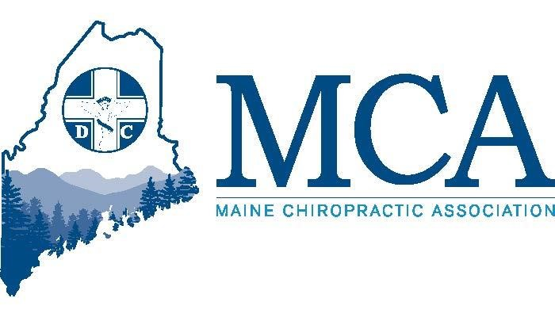
8 CE Hours Offered
2 Tracks for Maine Chiropractors
1 Track dedicated for Staff

May 15th, 2021
From the comfort of your home or office!

The MCA is excited to provide our virtual conference, featuring 8 hours of Continuing Education, our annual Business Meeting and Exhibitors sharing the latest tools and services for the Chiropractic Community!

Join Us!

Exhibitor Showcase
During the day we will have open a virtual exhibitors hall where our sponsors and vendors will be available with handouts and information on their products and services. We urge you to take a few minutes to stop by their virtual boots and thank them for supporting the MCA.
MCA Registration

MCA Members $ 99.00 Early Bird $129.00 after 4/30/21
Non-Members $ 129.00 Early Bird $159.00 after 4/30/21
Staff $20.00 (1 Free staff if DC registered)

Attendee Name(s): Email also required to send link for presentation.
1. ____________________________________________________________ name _______________________________________________________________ email
2._____________________________________________________________ _name _______________________________________________________________ email
3.______________________________________________________________name _______________________________________________________________ email

Register by e-mail (Mainechiroed@gmail.com) by fax to (207) 782-5482 or by mail to:
Maine Chiropractic Association, 58 Albert Street Lewiston ME 04240
Payment Options:
____ Check enclosed.
Please charge $ _________ to my ____VISA ____Mastercard _____AM EX
Name on Card (as shown) ___________________________________________________
Signature: _______________________________________________________________
Credit Card # ______________________________________ Expiration Date: ___________
Zip Code: ______________________

This program is approved for 8 Hours Category 1 Continuing Education in Maine
Professional Development Track

Saturday 8:00 AM – 10:00 AM & 10:30 AM – 12:30 PM (Break @ 10:00 AM)
Track 1
Enrique Flores, DC, CFMP, CME
Practical Diagnosis, Assessment, Recommendations & Treatment Tools for the Foot & Knee
Dr. Flores explores the most prevalent causes of pain, disease, degeneration, and corrective measures as they relate to the Foot and Knee. He offers practical ideas for the evaluation and treatment of the active patient as well as insight into effectively communicating these ideas to patients. This program allows the practitioner to offer simple condition-based care, and to be able to make a proper referral to other specialists if needed. A correlation to teachings regarding basic pathology will be addressed.

Track 2
Miles Bodzin, DC
Care Plan Recommendations and Patient Retention
Attendees will gain nuts and bolts information about their care plan recommendations, including state and federal compliance issues regarding payment plans, credit card auto-pay programs and discounts. These tools will help the office of today streamline the systems in their practice.

Track 3 (This track is for staff)
Jeff Lewis – Sponsored by Eclipse Software
Bullet-Proof Your Practice: Keys to Creating Audit-Proof Documentation – Join other chiropractic staff as Jeff explores creating and maintaining an audit-proof records system (2 hours)

Coding 101 in 2021: Overview of New Coding Guidelines for 2021 - In this second session, Jeff will cover all the latest coding changes and guidelines for 2021 what we know might be coming 2 hours)

MCA Business Meeting 1:00 PM – 2:00 PM
Join members on a zoom call as we have our annual business meeting. Agendas and reports will be provided a few days before the event. Learn what the MCA is doing during the pandemic and what our plans are for the future. This meeting is scheduled to include election of Officers and Board Members.

Saturday 2:00 PM – 4:00 PM & 4:30 PM -6:30 PM (Break @ 4:00 PM)

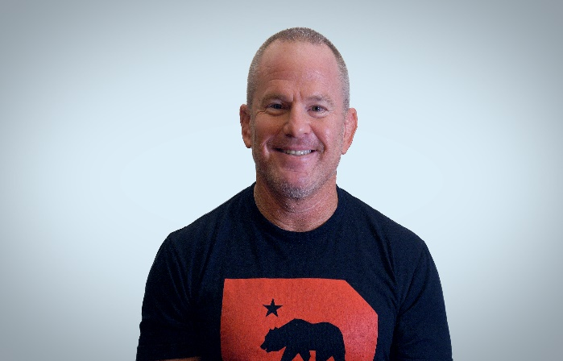
Track 1 (This track is also appropriate for staff)
Dr. Ethan Kreisworth. Ph.D.

“Dr. K” will cover Kinesiotaping Redefined – Taping Movement not Muscle during the first two hours followed by 2 hours on the latest in Instrument Assisted Soft Tissue Mobilization (IASTM). This program is designed for the Chiropractic Doctor but may also be helpful for clinical staff in your office.

Track 2
Steve Conway, DC, Esq.
The Medicare Compliance seminar: The “just show me what to do” seminar for understanding required Medicare documentation, rules, and regulations for proper compliance.
This program will define and demonstrate proper Medicare compliance procedures with an emphasis on proper documentation to reflect the services provided, provide in-depth analysis of initial visit and subsequent visit requirements, and distinguish between what is fact and fiction related to “opting out” of Medicare.

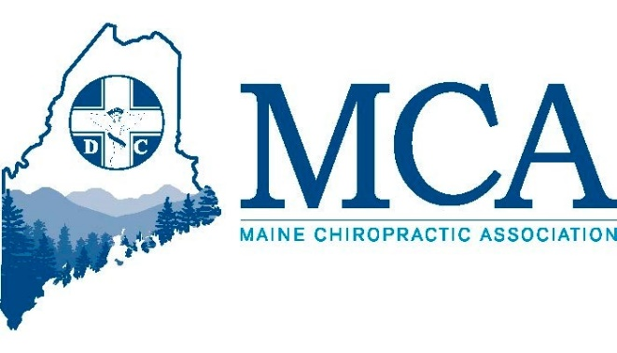

May 6, 2021

Doctors,
I am excited to announce our 2021 Spring Virtual Conference speakers and program at this time. While the state has begun lifting some of the restrictions on gatherings, those decisions were not made in time for us to organize an in-person event at the Samoset. In addition, we could not risk planning an event that later needed to be cancelled should the pandemic worsen. We do look forward to meeting in person for our Fall event.
The spring virtual conference will be one day Saturday May 15th – and include 8 hours of Continuing Education as well as our MCA Business Meeting. As you can see from the enclosed flyer, the program will have you choosing from 2 different tracks in the morning and afternoon, so there is something for everyone. We have also worked with the MCAA to offer 4 hours of staff training that is more billing, coding, and front desk (morning) and invite clinical staff to join our Doctors in the Kinesiotaping program in the afternoon. With your paid registration you will have one complementary staff registration allowed at no charge.
As always suggestions are welcomed for future speakers, both at conferences and for our webinar-based programs – we expect those to continue long after the pandemic conditions subside. Make sure to mark your calendars for October 22nd – 24th when we plan to meet in person at the Sable Oaks Sheraton for our Fall 2021 Conference where we kick off our plans for 2022 – the 100th anniversary of Chiropractic in Maine.
Yours in Chiropractic,

Robert Reed, Executive Director
Maine Chiropractic Association

