MCA Spring Conference 2020
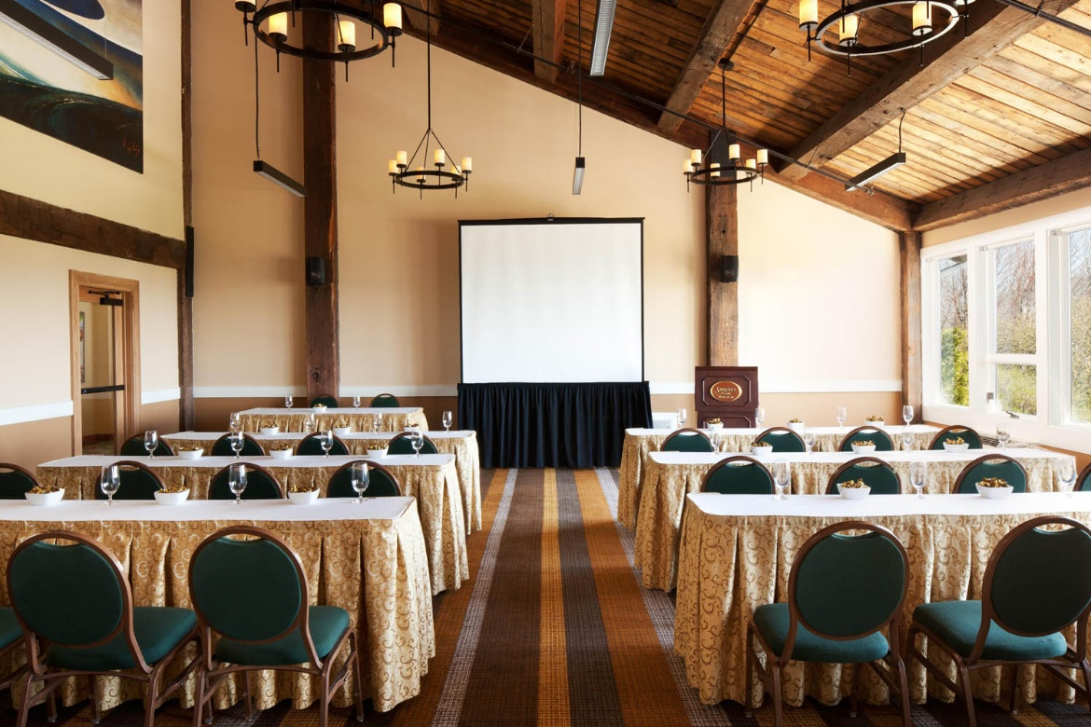
Committed to Chiropractic Excellence

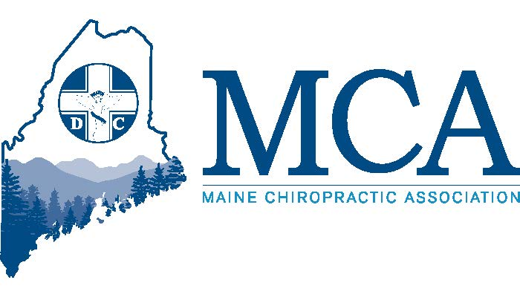

April 24th – 26th Samoset Resort, Rockport Maine
Contact the Samoset at (207) 594-2511 for rooms and mention the MCA Discount or go to:
https://reservations.samosetresort.com/samoset/?startDate=mm/dd/yyyy&endDate=mm/dd/yyyy&requesttype=invBlockCode&code=MCA20
Track 1 – For Todays Chiropractor

“The Case For A Plant-Based Diet”
Howard Cohn, DC of Cohn Health Institute
Friday 6:00 PM – 8:00 PM Dinner Provided by the MCA
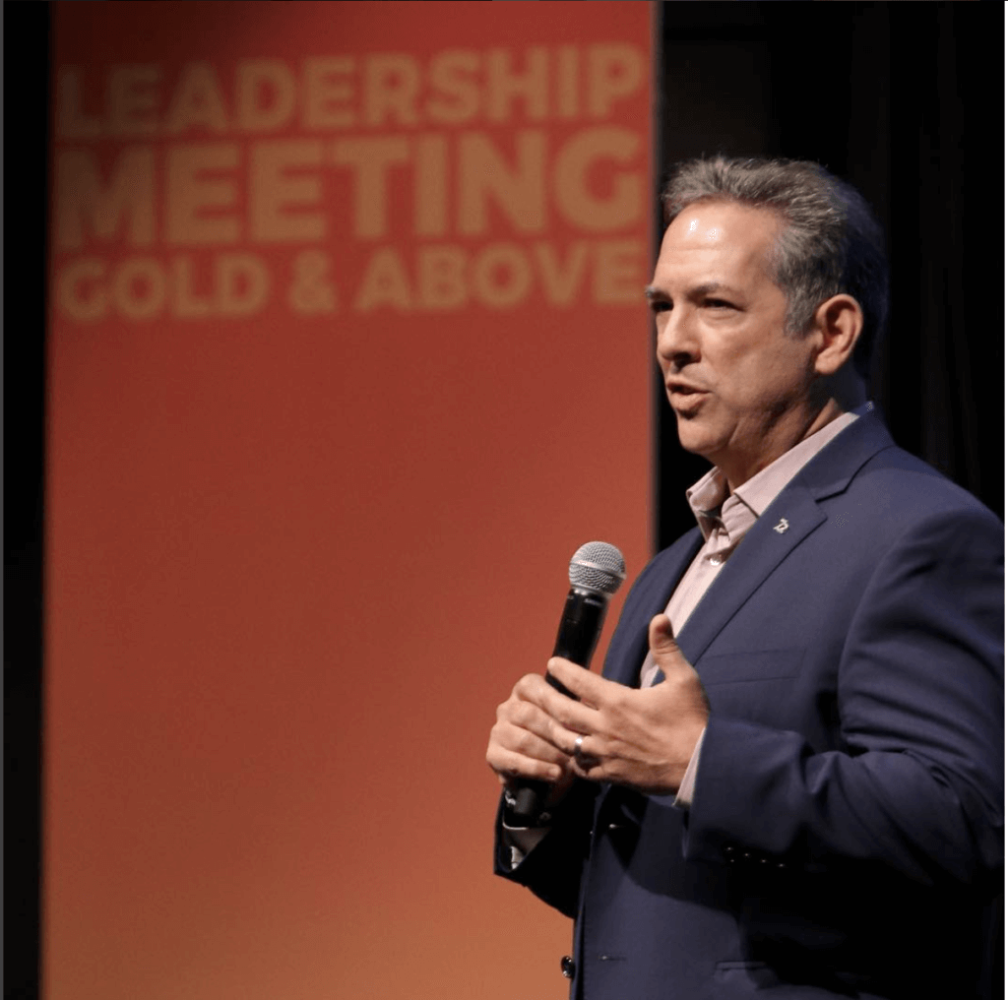
The Case For Plant-Based, Organic Nutrition & Molecular Hydrogen, A Scientific Miracle. This talk will discuss the benefits on global human health from eating a diet rich in plant-based, organic, alkaline foods. We will also discuss supportive nutritional supplementation strategies for the everyday chiropractic practice to for better clinical results with patients as well as increased profitability in the practice. 2 CE Hours, Sponsored by Life By Seacret
Dr. Howard Cohn is President and Founder of the Cohn Health Institute and has lectured and taught throughout the country on the subjects of diet, nutrition and natural and alternative healthcare for over 2 decades. Dr. Cohn believes the body was designed to heal itself as long as it’s given the correct building blocks in order to do so and is allowed to function free of interference.

Aligned Continuing Education
Dean DePice, DC
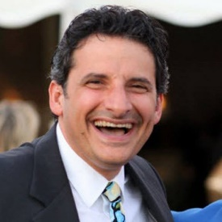
Saturday, 8:00a-12:30p, 2:00p – 6:00P & Sunday 8:00a – 12:30p

Join Dr. Dean DePice in a journey drawing upon the most recent research in science and philosophy designed to promote patient outcomes through greater knowledge of chiropractic’s safety. Topics covered will include “Strokes Uncovered”, “Daily Patient Notes”, “Wellness, More of This, Less of That”, “The War Within”, “Health Reform/Self Reform”, “The Time is Now for Chiropractic”, “Chiropractic – On The Precipice of Revolution” and many more topics designed to promote discussion and better understanding.
12 CEs possible. Sponsored by Chiro Touch.

Dr. Dean DePice has been adjusting atlases and cultivating thriving practices with TLC Coaching for decades. Together with his wife, Dr. Jen, both Life University alumni, he raises up vibrant Chiropractic Teams & Families. Practicing Chiropractic since 1987 and Coaching Chiropractic Teams & Families with TLC Coaching since 2001, Dr. Dean is a tireless servant to his patients, to us, his colleagues, and to our great profession. From his collegiate grounding in Chemistry and Biology to his decades of hands-on experience adjusting spines and fanning practices into blazing infernos of healing and growth, he is uniquely perched as a Chiropractor-Coach. Dr. Dean, in his insatiable intellectual curiosity, ferociously translates Chiropractic principles and procedures into vibrant patient and practice outcomes.

Track 2 – For The DC & Staff

KINESIOTAPING, CUPPING AND MORE
Raphael Castro, DC
Saturday, 8:00a – 12:30p & 2:00p – 6:00p
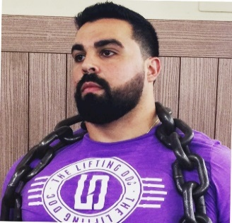
Join Dr. Castro for 8 hours of kinesiology, including 4 hours of the Effects and Benefits of Kinesiology Taping and Posture discussion, as well as 2 Hours training on Myofascial Cupping followed by 2 hours of Compression Band Flossing. Participants are encouraged to wear comfortable clothing for the day as this will include hands on workshops throughout the presentation. 8 CE’s possible. Sponsored by Rock Tape Inc.

Also known as The Lifting Doc, Raphael Castro is a sports chiropractor from New York. He received his Masters of Sports Injury Management/Rehabilitation and his Doctorate of Chiropractic from Life University. His current practice in upstate New York is limited to the treatment of athletes and active individuals. Dr. Castro is an active competitive powerlifter and heavily involved in the Powerlifting and Crossfit communities.

“The Case For A Plant-Based Diet”
Howard Cohn, DC of Cohn Health Institute
Sunday 8:00a – 10:00a
The Case For Plant-Based, Organic Nutrition & Molecular Hydrogen, A Scientific Miracle. This talk will discuss the benefits on global human health from eating a diet rich in plant-based, organic, alkaline foods. We will also discuss supportive nutritional supplementation strategies for the everyday chiropractic practice to for better clinical results with patients as well as increased profitability in the practice. 2 CE Hours, Sponsored by Life By Seacret

“How To Properly Do An In Office Health Workshop”
Howard Cohn, DC of Cohn Health Institute
Sunday 10:30a – 12:30p
Want to offer an in-office health workshop guaranteeing new patients? Most Chiropractors have abandoned doing an in-office lecture due to poor attendance and lack of results. This talk will show you step by step how to drive traffic to your health workshop from both in & out of your office as well as the simple, duplicatable steps to have a greater than 100% close rate for new patients
Dr. Howard Cohn is President and Founder of the Cohn Health Institute and has lectured and taught throughout the country on the subjects of diet, nutrition and natural and alternative healthcare for over 2 decades. Dr. Cohn believes the body was designed to heal itself as long as it’s given the correct building blocks in order to do so and is allowed to function free of interference. 2 CE Hours, Sponsored by Life By Seacret

MCA EVENT REGISTRATION
Early Bird Discount (Ends 4/10/20) Late Registration
MCA Member Doctor $279.00 _____ $349.00 _____ ____ Include Dinner Friday (no charge for DC’s)
Non-Member Doctor $379.00 _____ $449.00 _____ ____ Include Dinner Friday (no charge for DC’s)
Staff – Saturday Program $ 50.00 _____ $ 75.00 _____
CA/Staff Friday Dinner $ 30.00 _____
Attendee Name(s): __________________________________________________________________
____
Address: ___________________________________________ City _________________ ZIP _________
Register online at www.mainechiro.com, by secure fax (207) 782-5482 or by mail to:
Maine Chiropractic Association, 58 Albert Street Lewiston ME 04240
Payment Options:
Please charge $ _________ to my ____VISA ____Mastercard _____AM EX or Check # _________________(enclosed)
Cardholder Name: _________________________________Signature : _______________________________________
Credit Card # __________________________________________________ Expiration Date: _____________

