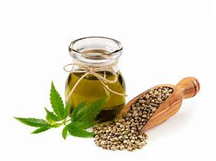
CBD OILS -WHAT YOU NEED TO KNOW
Contemporary Cannabinoid Science
And Clinical Use
Bangor & Portland locations

Many providers are challenged with patients who ask about use and expectations regarding CBD oils, especially concerning pain relief. This program will give attendees the information necessary to help patients make informed decisions regarding cannabinoid use including those made from marijuana, hemp and other sources as well as answer questions to help you decide whether to offer the products in your office.
This 4 hour program will cover the basic science of Cannabinoids including the history, how they work and any relationship to substance abuse disorders, and the clinical understanding – forms and mechanisms for delivery, the clinical indications and what we know so far in relation to chronic pain, muscle spasticity, gastrointestinal issues, sleep and epilepsy and any contraindicated conditions as well as other areas of concern.
This program is sponsored by the Maine Chiropractic Association and taught by staff at the University of New England. There will be no vendors present as we seek to provide objective, unbiased answers based on the latest research. Informational packets on products from various companies will be available to all participants should you want more information.
This program is offered to all clinicians as well as retailers and the general public. Approved for 4 Hours CE by the Maine Chiropractic Licensing Board, Pending request to NH Chiropractic Licensing and MAAOM.
Northern Maine Southern Maine
March 9, 2019 10:00 AM – 2:00 PM March 16, 2019 9:00 AM – 1:00 PM
Husson University - Libra Lecture Hall University of New England – Innovation Hall
1 College Circle, Bangor ME 04401 772 Stevens Ave, Portland ME 04103
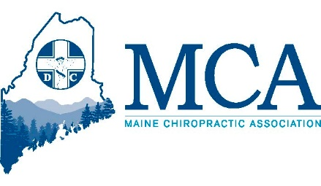
Registration
Name: _______________________________________________________________
Address: _______________________________________________________________
Email: _______________________________________________________________
Additional Attendees: ____________________________________________________
Credit card: ____________________________________ Exp:________ CV code________
Name on card (if different from registrant: _________________________________________
Cost: $59.00 per person, $79.00 day of event, includes all handouts and light refreshments during the presentation. Refunds will be made if program is cancelled or if notice given at least 7 days prior to event.
Location Choice _____ Bangor _____ Portland
Register online at www.mainechiro.com or -
Payment by check or credit card to Maine Chiropractic Association, 58 Albert ST Lewiston ME 04240
Or by fax to (207) 782-5482 or email to mainechiroed@gmail.com (fax or email for credit cards only)

About the Speakers
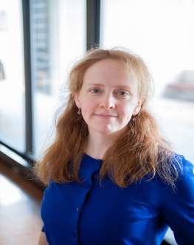
Selma Holden, MD is a Family Medicine physician with additional training in integrative medicine and public health. She completed her residency training at Maine Dartmouth's Family Medicine Program in Augusta. She's worked in integrative medicine clinics in Maine and Massachusetts and completed a Post-Doctoral Research Fellowship in Integrative Medicine. At UNECOM, she teaches first and second year students and provides clinical service through UNE's MatureCare group. She directs a HRSA fellowship that trains primary care providers on how to help patients with substance use disorders.

David Mokler, PhD is Professor Emeritus of Pharmacology in the College of Osteopathic Medicine at University of New England. He has taught at UNE COM for 32 years. His area of research is the neuroscience of drugs of abuse and serotonin. He has published over 60 papers in peer-reviewed journals.

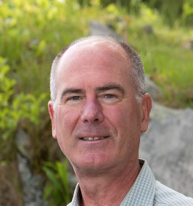
Geoffrey M. Bove, DC PhD is a biomedical researcher and chiropractor, internationally recognized for his expertise in pain physiology and its treatment using manual therapies. His contributions to the literature include the first characterizations of nociceptors innervating the paraspinal structures, the dura, and the fascia of nerves. Dr. Bove’s original data papers and reviews have been published in major journals including Pain, Journal of Neurophysiology, Physiology, JAMA, The Lancet, and many more.

