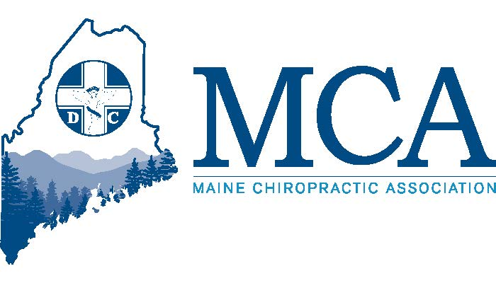

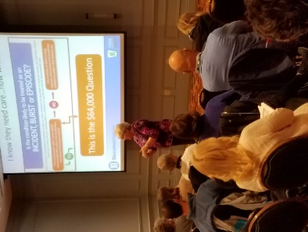
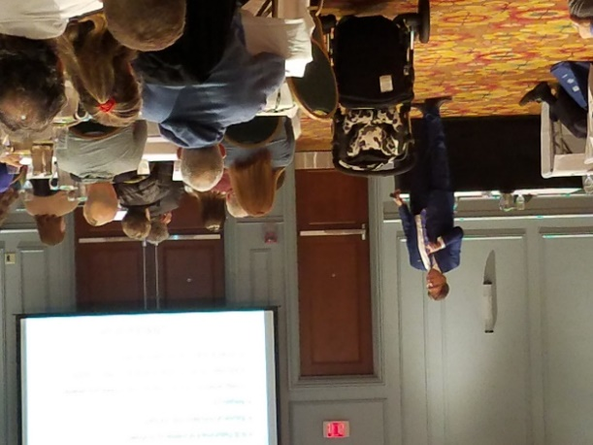
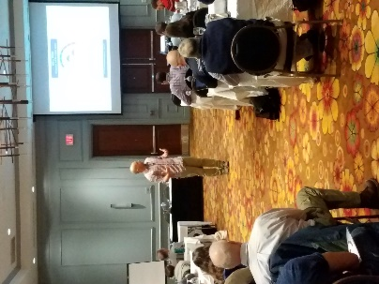
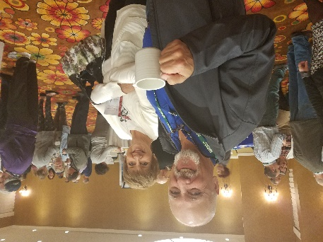
“Medicine is the study of disease, and what causes man to die. Chiropractic is the study of health and what causes a man to live” – BJ Palmer
MCA
FALL
CONFERENCE
January 2019

From the Office of The President

Season’s greetings and Happy New Year to everyone,

What a great turnout for our recent fall conference – with 175 doctors and 60 staff we filled the rooms and made our speakers and vendors very happy. My thanks to all who supported the event by attending or working during the event. I thought I’d use my space here to provide updates on what your Board has been working on and where we are headed.

On the legislative front, we support actions in Washington DC around Medicare and the VA which will expand access and services under chiropractic care. More locally, the Legislative Committee has begun the process to present several bills to the State Legislature for consideration, much of which is covered in John Royce’s remarks later in this newsletter. In looking at election results, we believe the incoming Governor and Legislature will be friendlier towards all things chiropractic and believe we are well positioned and look forward to working with them.

On the insurance carrier front, we’re seeing some minor issues with Aetna and Anthem that we have begun to address and we continue to monitor the favorable changes we helped implement at Community Health Options. Our hope is for a smooth transition and a stronger voice with CHO moving forward – something that could include board membership, chiropractic advisory committees and other discussions which could place Maine as a model for other carriers in Maine and throughout the country. As that latter item is still in discussion and confidential, we’ll reserve further comment until something more concrete is ready.

For 2019, we’ve made a commitment to a series of brochures about chiropractic care which will be distributed throughout the state in medical offices, health fairs and other events which will educate and offer the MCA doctors as a resource for treatment. We expect this to lead to more referrals for your offices and wider acceptance of chiropractic care for physical medicine care and as a gateway to more integrated care models.

The website continues to develop, and we’ve begun the process of stocking the library with our by-laws and minutes of board meetings. Soon we’ll add online continuing education at discounted rates for our members and other items of interest. If you think of anything you’d like to have added or considered, please speak with our Executive Director who manages the site. Make sure you’re looking at the marketplace site for your needs or to advertise when you need help or equipment. Most ad space is free to members and we’d like to fill the listings.

As we end 2018, we look back at what we have accomplished and feel good, yet we know we have so much more to do in 2019 and have set lofty goals as an organization. With your help, we will continue to lead the way for chiropractic in Maine. The association is strong and vibrant and willing to grow and help its members.

In closing, again my thanks for all your support and I want to wish everyone happy holidays and a prosperous year ahead.

Best,

Luc J Dionne DC, President MCA
Legislative Updates

Andre Nadeau, Legislative Chair
&
John Royce, Legislative Lobbyist

We are currently working on four legislative proposals for this legislative session of the 129th Maine legislature. The first one is a Mainecare fee increase bill that we passed the legislature with last session but could not get funded. It is time to try again and hope we can get it to the Appropriations table and achieve funding, which is always a difficult task. The next bill is a full scope Mainecare reimbursement bill. Last session we passed legislation to reimburse for the exam under Mainecare so now we are going for full scope. This is difficult legislation but we feel it is important to make a strong case. We are also pursuing legislation related to the Opioid issue. It will include some language from the West Virginia law that encourages primary care providers to refer to nondrug providers for chronic pain treatment before patients are given opioids. Lastly, we are submitting a proposal regarding chiropractic interns and defining what they may be allowed to provide for treatment, to equal what other states are allowing.

Dr. Andre Nadeau and I met with the Mainecare medical director on Thursday December 13.
Mainecare is in the process of implementing rules to cover payment for all exam codes Chiropractic utilizes. The rules will not be fully implemented until early February.

I also met with Gordon Smith of the Maine Medical Association and there is a real likelihood he will be the new opioid czar for Governor elect Mills. If that happens, he will be the person we will be working with to assure Chiropractic is part of any solution to the opioid problem.

The essential benefits package under the Affordable Care Act will also be up for reconsideration this session and we will be very involved in defending our inclusion.

It will be a very busy legislative session in regards to healthcare and insurance issues.

Respectfully,

John Royce

News From the MCAA

I would like to take this opportunity to introduce myself. My name is Rachel Soucy and I am the new President of the Maine Chiropractic Assistant Association. I look forward to the excitement of the New Year. I know that some of you have wondered what the MCAA can do for our office. Have you ever had an insurance question that you just don’t know the answer to? Do you ever wonder how you could be more streamlined and efficient? Do you ever wonder as a doctor how I can have more time with patients? We can certainly help you with those answers. One that is very important is how I can as a doctor spend more time with my patients. If you had a licensed CA!! If you had a licensed Chiropractic Assistant in your office, they would be able to perform Ultrasound on patients which could free the doctor for 15 minutes, E-stim which could free the doctor for 10 minutes, perform certain aspects of an exam which could free the doctor for 15 minutes. Now those times are estimates, but with that time being saved by having a licensed CA, you would be able to see more patients. Isn’t that awesome! Our next Clinical Class for licensed CA’s will be starting in March. The dates will be:

March 2-3, 2019 – Sable Oaks Marriott, S. Portland
March 16-17, 2019 – Hollywood Slots, Bangor
March 30-31, 2019 – Augusta/Waterville, TBD

We are looking at having one day seminars regionally located to address topics such as scripting, how to schedule, insurance, introduction to being a chiropractic assistant. We are always open to ideas and what your office needs may be. I can be reached at msoucy8@roadrunner.com or (207)623-8550. Please feel free to contact me in regards to the upcoming CA module class or have any ideas that you would like to see come forth.

Yours in service,

Rachel Soucy
President/Clinical Class Coordinator

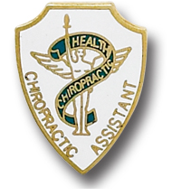

Office Notes from the Executive Director

As we begin 2019, it’s nice to look back at 2018 and celebrate our successes while planning for even more in 2019.

Our legislative team was able to pass exam coverage under Mainecare and then worked with Mainecare leadership to change the referral process. In 2019, we’ll submit robust legislation covering several topics and we’ll keep working with Mainecare’s new leadership team to further develop better coverage and ease of access.

A separate group spent significant time battling EviCore over the past 13 months. While it took longer than we hoped, we are happy that EviCore will no longer review chiropractic services and that the overall process will be much friendlier to us. Moving forward, we will have a larger voice at Community Health Options with a Chiropractic Advisory Board.

We’ve also gotten new benefits for credit card processing that some offices are now saving as much as $400 per month in their processing fees. We’ve extended the offer of a free fall seminar registration through the end of January for any office deciding to sign up for the program. It’s guaranteed to beat your current rates and it supports the MCA!

We’ve also contracted with Clear Estimates to give MCA members exclusive best rates for their services. Imagine the time you can free up for staff by going online to verify benefits, check deductible, copay or visits instead of waiting on the phone on hold. Real time data at your fingertips and at a time that’s most convenient to you.

It is my pleasure to continue to work with the MCA President, Board of Directors and Members to promote Chiropractic care in Maine. I look forward to what 2019 brings to this association.

Yours in Good Health,

Robert A. Reed
Executive Director, MCA

Calendar of Events

MCAA CA 2019 Course
March 2-3, 2019 – Sable Oaks Marriott, S. Portland
March 16-17, 2019 – Hollywood Slots, Bangor
March 30-31, 2019 – Augusta/Waterville, TBD

MCA CBD Oils – What you need to know
Locations being determined – 3 – 4 hour program
March 2019

MCA Membership Re-enrollment
March 15, 2019 1st Half dues

MCA Spring Conference - Samoset Resort
May 3– May 5, 20198

MCA Board of Directors
May 5, 2018 (Samoset Breakfast)

MCA Fall Seminar – Marriott at Sable Oaks
October 27 – 29, 2019

Member Classified Ads

Member classifieds have moved to our website, please visit www.mainechiro.com to review or place an ad (free to MCA members).

When we have an opportunity, we would like to showcase some of our vendors knowledge and products or services that may be new to the marketplace. This is NOT an endorsement of any kind but an opportunity to expand our understanding.
Vendor Voices

This article on preventing fraud comes to us from our partners at EvoPayments, formerly Nationwide. Evo offers credit card processing with substantially lower rates than you might currently be charged AND provides a small referral to the MCA for each account under our agreement. This is a member benefit only and we’ve already seen doctors saving $200-$400 per month in those expenses by making the switch – so what are you waiting for?

How Medical Professionals Can Prevent Cyber Attacks

The medical field is filled with a plethora of patient information ranging from financial data to medical history. Their security is crucial to a successful business, but the threat of cyber-attacks and data breaches are real. According to the Consumer Sentinel Network, “Within the fraud category, imposter scams were the most reported and ranked first among the top 10 fraud categories identified by the FTC. They accounted for $328 million in losses.” We outline several ways doctors and their staff can take preventative measures.

- Beware of suspicious emails/senders. Have you ever received an email and were unsure of what the email was about or where it came from? Does the email address look familiar, but the spelling of names is slightly off. Those little nuances are exactly what scammers want you to fall for.

- Do not click unfamiliar links or downloads unfamiliar attachments. Links and attachments in emails are instant entryways for malware that can provide access to personal information. Install a firewall, or network security system to monitor incoming and outgoing traffic within your office.

- Don’t fall for free product trials. Rarely is anything free these days. The Better Business Bureau says, “Complaints about free-trials doubled between 2015 and 2017 and those consumers who complained lost an average of $186.” In the medical industry, these free trials may be common, but use common sense and follow up to make sure.

- Protect personal information. This point should seem like a no brainer, but sometimes a phone number, or birthdate can slip out. Never share that information whether it’s to another patient or someone externally. No matter how personal, in-house records and financial information should never leave the office.

The old adage if it seems too good to be true, then it probably is, should be your warning sign. If you don’t know who an email is coming from, are unsure of the link, or a company is offering something that seems fishy and wants your personal info, stop and follow through. Research the company and call them directly to ask if it is legitimate or not.
MCA Member Benefits

VIP Tires & Service
- $10 off every oil change
- 5% of Tire purchases
- 10% off parts and labor
U.S. Cellular
- 15% off personal phone plans for employees
- 15% - 20% off business plans for the office

Hertz Rental Cars
- 25% off standard rental rates (use our CDP#0002117987)
TD Bank
- Credit card processing discount
- Affinity Merchant Servicing

- Staples Business Advantage Discount Program, Discounted office supplies in person or ordered online, plus 25% off copying, 10% bathroom and cleaning supplies, Car rentals, flower deliveries and more.

Advance Collection Services - 25% flat fee for collections of accounts placed
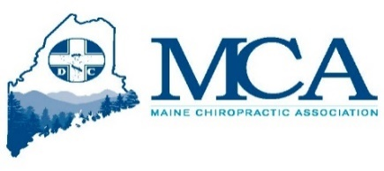
MCA Website, designed to provide information to the Chiropractic community and those seeking care. Including a search engine to find an MCA doctor nearby www.mainechiro.com
Nationwide Processing
- Credit Card processing fees that will guarantee the lowest rates offered in Maine to members of the Maine Chiropractic Association.
The Maine Chiropractic Association now offers a help desk to assist with a variety of issues your office may face – including billing and reimbursement, training, and much more. Got a quick question or want a second opinion (non-clinical), call us for help!

