MCA Spring Conference 2019

Committed to Chiropractic Excellence
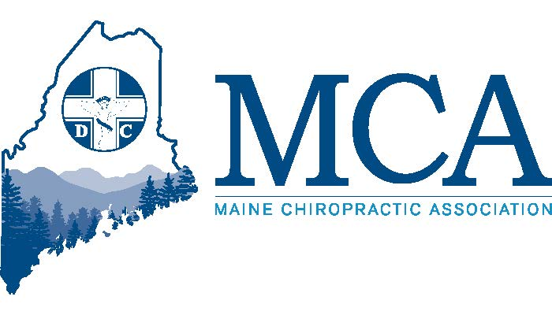

April 26th – 28th 2019
Samoset Resort, Rockport Maine
Room Reservations: Samoset Resort (207) 594-2511 or www.samosetresort.com
Mention the MCA Discount

Track 1 – For Today’s Chiropractor
Monika Buerger, DC
Saturday, 8:00am-12:00pm
Balancing the Brain, Chiropractic Style!

Concussions, mild traumatic brain injuries, spinal injuries, infections, and even modern day “tech neck” can lead to brain imbalances. In this dynamic lecture, Dr. Buerger will address the role of the vestibular and interoceptive sensory systems in relation to their critical influence on immune function, mood, depression, anxiety, cognition and autonomic regulation. The vestibular system is the “air traffic controller” of all the sensory information into the CNS and is key in regulation of all sensory-motor function. In addition, she will discuss the critical role chiropractic care plays in the development, function, and regulation of these sensory systems, giving attendees more confidence and certainty on the WHY and HOW chiropractic affects brain function! Don’t miss Dr. Buerger’s many “take home pearls” to implement into your practice on Monday! 4 CEs possible. Performance and Ordering of Tests. Sponsored by Intersect4Life.

A 1991 Life Chiropractic College-West graduate, Dr. Monika Buerger is an author, national, and international lecturer in the field of functional neurology and functional medicine. She and Dr. Heidi Haavik will be traveling the world together in 2019-2020 educating the masses. She is part of the International Chiropractic Pediatric Association’s seminar program, where she offers a course on Neurosensory Integration and Sensory Processing Disorder.

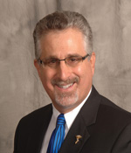
Mitch Mally, DC
Saturday, 1:30pm-5:30pm
THE SECRETS OF SCAPULA DYNAMICS IN SHOULDER CONDITIONS, INJURIES AND SYNDROMES

Shoulder injuries account for a tremendous battlefield for practitioners and a field of agony for the patient, both financially and physically. This class arms the doctor with evidence-based science and research to be better equipped with various drugless and non-surgical treatment options afforded the patient.

Sunday, 8:00am – 12:00pm
FOOT AND ANKLE CONDITIONS, INJURIES AND SYNDROMES
This course focuses on normal vs abnormal foot/ankle mechanics and common conditions such as: Plantar Fasciitis, Morton’s Neuroma, Heel Spur Syndrome, Tarsal Tunnel Syndrome, Sprain/Strain, Bunions, and more. Attendees will learn gait mechanics plus Hands-On technique demonstration(s). 8 CE’s possible. Sponsored by Multi Radiance

A 1981 graduate of Palmer, Dr. Mitch Mally is an international author, lecturer, and leader in research, with an emphasis on carpal tunnel syndrome, cumulative trauma disorders, TMJD, and congenital leg length morphology. He has lectured for many state associations and national conventions and audiences, including chiropractic, dental, medical, osteopathic, and specialists in orthopedics, neurology, and radiology. He has established the non-surgical protocol for the treatment and prevention of CTS and CTD that is considered by many as the benchmark in the chiropractic profession. He is also a team teacher for Parker Seminars.

Track 2 – Rockland Ballroom – DC/CA

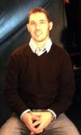
Scott Nevers, Founder Nevers Medical Group
Friday 5:30pm – 7:30pm Dinner Provided by the MCA
“The ABC’s of AED’s”

Learn why every office should consider having an AED device for employees and patients and what training is required for proper use. Hear how one mans near tragedy lead to the founding of this company in Southern Maine.

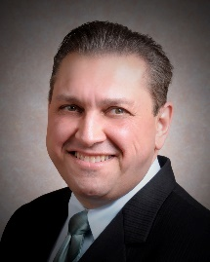
Mario Fucinari, DC CCSP®, APMP, MCS-P, CPCO
Saturday, 8:00am – 10:00am
Effectively Communicating the Chiropractic Story

Nine out of ten new patients coming into your office have never been to a chiropractor before. The methods you use to communicate the “chiropractic story” will not only prevent medical errors but will help to ensure better compliance and outcome of your treatment. Dr. Mario Fucinari has been in chiropractic practice for over 31 years. He will present timely methods to effectively communicate to your patients, staff and the general public. 2 CE’s possible. Sponsored by NCMIC

Saturday, 10:00am – 5:30pm
Health Care Updates for the Chiropractic Office

This is the year to remember in the world of healthcare policy. From a budget law with over 300 pages of healthcare provisions, a proposed overhaul of Medicare’s E/M documentation and payment system, expansion of the VA referrals to chiropractors, changes in Blue Cross policies and HIPAA audits to increased claim analysis with ICD-10 coding, this year is packed with important regulatory changes that are sure to impact your office for years to come.
Having trouble keeping up with the latest changes? Join our class to hear Dr. Mario Fucinari, a Certified Professional Compliance Officer and a Certified Medical Compliance Specialist discuss the latest developments and what they mean for your practice. Dr. Fucinari will show you how to incorporate the latest developments into your practice, without giving up your chiropractic roots. Perfect for doctors, staff and billers. 6 CE’s possible. Sponsored by NCMIC

Dr. Mario Fucinari is the first chiropractor to attain the Certified Medical Compliance degree. Two years later he earned his degree as a Certified Instructor for the Certified Medical Compliance Program, and he is now the Chairman of the Chiropractic division of the national medical compliance program. He has produced classes and publications on HIPAA, Clinical Documentation, Medicare, and Stroke and Cervical Manipulation. He is a worldwide speaker for NCMIC and several state associations. A graduate of Palmer, Dr. Fucinari served as class historian, class Vice-President and eventually as Class President

Sunday, 8:00am-12:00pm
Dr. Bob Scott
Clinical Strategies Addressing Inflammation and Metabolic Health

Overview of the endocannabinoid system with discussion of the benefits of hemp oil and the safe and legal use of hemp oil: inflammation and beyond. Review of cardiometabolic disease. Learn nutritional and herbal strategies addressing the chronically inflamed patient.
MCA EVENT REGISTRATION
Early Bird Discount (Ends 4/16/19) Late Registration
MCA Member Doctor $250.00 _____ MCA Member Doctor $325.00 _____
Non-Member Doctor $375.00 _____ Non-Member Doctor $450.00 _____
Chiropractic Students $ 50.00 _____ Chiropractic Students $ 75.00 _____
MCAA Members (CA’s) $ 30.00 _____ MCAA Members (CA’s) $ 45.00 _____
CA/Staff Friday Dinner $ 25.00 _____
Doctor Registration includes dinner Friday during the presentation. If staff wish to attend that presentation, we ask that they pay an additional $25.00 to offset cost of the meal.
Attendee Name(s): __________________________________________________________________
Address: ___________________________________________ City _________________ ZIP _________
Register online at www.mainechiro.com, by fax (207) 782-5482 or by mail to:
Maine Chiropractic Association, 58 Albert Street Lewiston ME 04240
Payment Options:
Please charge $ _________ to my ____VISA ____Mastercard _____AM EX or Check # _________________(enclosed)
Cardholder Name: _________________________________Signature : _______________________________________
Credit Card # “ ______________________________________ Expiration Date: _____________ CVV# ___________
